

Title: | WP Quiz & Test
Task/Lesson No. | Test out of 100
Class: | Publishing
Area: | Technology & Enterprise
Teacher: | Mr Faulks
Phone: | (08) 9310 0864
Contact email: | pfaulks@corpus.wa.edu.au

TITLE: Word Processing Worksheet Test

Time: 50 minutes (Start now)

NOTES:
This test is conducted on line open Microsoft Word

Complete as many numbered sections as you can

Items in grey you add your information
- Black text are for instructions (a) (b) etc.
- Blue italic text you amend alter or adjust

NOTE Change font and style back to suit (DO NOT LEAVE TEXT IN BLUE)
- The text in this document needs to be formatted, copied, moved, and otherwise edited.
- Follow the directions given. Check that you have done everything asked, check the set-out with print preview, and check that you have no blank pages.

School: Student Name Peter J Faulks

Class: 2006 Home Room: 8M2

Word Processing Assessment Exersizes for Y10 Publishing

Complete this test on line

(1). (make a folder called Marking if you do not have one!) Save this document as yourname_WP1.doc to your marking folder inside your Student Folder for this class i.e. Y10 Multimedia or Y10 Publishing
(2 Marks)
Table
(2). [a]. Create a table with 2 columns and 3 rows. In the first column put your top 3 favourite movies and in the second column your top 3 favourite songs.
(4 Marks)

Grease | The Joker
Enemy of The Sate | Love Me Do
Zulu | Reflections

[b]. Copy your table then add a column in between the existing columns and put your top 3 favourite colours.

Peter Faulks
Grease | Blue | The Joker
Enemy of The Sate | Red | Love Me Do
Zulu | Gold | Reflections

[c]. Insert a row above, merge the row and type you name.

[d]. Place a red border around the whole table.

[e]. Shade in the top row cell in any colour.

(3). Picture
In this section, insert a picture, any picture. Resize the picture so that, when printed, it will be about 4 cm wide and 3 cm high.
(2 Marks)

INSERT YOUR PICTURE HERE

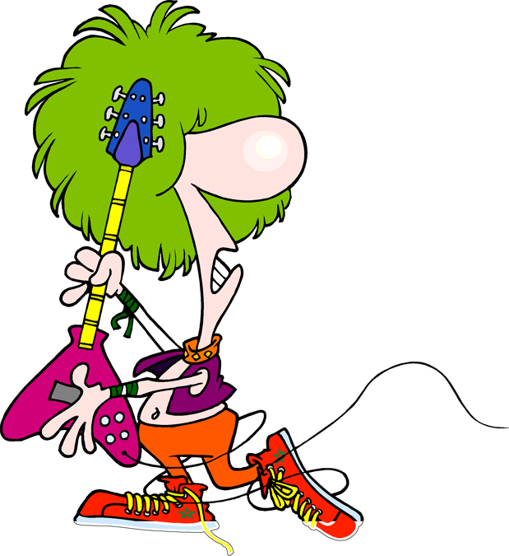

(4). WordArt
The button shown below was created with WordArt. Create your own WordArt logo for a Tour Company business below the button shown. When finished, place a border around your logo.
(3 Marks)

A Logo
Computing
Design

INSERT YOUR WORD ART HERE

This is my word art logo created by Peter Faulks

(5). From this list of names use the tab function to create a better looking list. Create:- First Name, Last Name, Gender (add gender)
(4 Marks)

First Name Last name Gender(Boy Girl)

Jailee Anthony Girl
Kate Ciccarelli Girl
Sara Cicchino Girl
Stephanie Hede Girl
Breanna Hill Girl
Christian Jaswan Boy
Adam Johnson
Sarah Kerr
Michael Lewien
Jasmine Linkston
Joshua Low
Jose Macapagal
Katie McNally
Stephanie Payne
Hayden Perich
Justin Polinelli
Rachel Santoro
Paloma Smith
Philippa Spurr
Patrick Thomas
Rachel Thomson
Hayley Vale
Blake Walsh
Sharni Warren

(6). Using the list of names from Grease use two tab functions Right Tab Left tab to create a cast list from the center of the page . Do not include commas change the font and colour. i.e.
Danny John Travolta
(4 Marks)

Danny John Travolta,
Sandy Olivia Newton-John
Betty Stockyard Channing
Principal McGee Eve Arden
Teen Angel Frankie Avalon,
Vi Joan Blondell
Vince Fontaine Edd Byrnes,
Coach Calhoun Sid Caesar,
Mrs Murdoch Alice Ghostley,
Frenchy Dody Goodman

(7). Create a list of names using several tab functions to create a price list for the School Ball. Ensure you use the decimal tab and put each under each tab
(4 Marks)

SCHOOL BALL COST

Item Type Cost

Men’s Suit Black $329.95
Ladies Dress White $299.00
Men’s Shoes Black $79.95
Ladies Shoes Red $99.95
Gentleman’s Shirt White $34.85
Ladies Shawl Cream $84.85
Scarf Red $18.45
Tie Gold $18.65
Stockings Grey $6.99
Socks Black $9.95
Tickets School Ball $75.00
Limo Deluxe Limousines Transport $150.00

(8) First, chek the speling of all the words in the document. Their are a number of mistakes which need to be corrected. Check the spelling now - particularly of the next section where there are a number of spelling errors.
(2 Marks)

Hav you ever expereinced the thrall of gliding noiselesly threw the air in a ballooon? Ballooning dates bak to th 1700's qith the first manned balloon flite taking place in 1783. A holiday to Central Australya is hot complet without a balloon flight over the spectracular scenary near the MacDonnell Ranges. What a thrill to see kangaroos and wallibies as they florage for food in the morning and to watch the sunrise.

Have you ever experienced the thrall of gliding noiselessly through the air in a balloon? Ballooning dates back to the 1700's with the first manned balloon flight taking place in 1783. A holiday to Central Australia is not complete without a balloon flight over the spectacular scenery near the MacDonnell Ranges. What a thrill to see kangaroos and wallabies as they forage for food in the morning and to watch the sunrise.

When you have finished all the editing of this document, especially the paragraph above, you should proofread it. There are a number of mistakes which, though they will pass the spell checker, are incorrect. For instance, typing their instead of there, or ring instead of rang.

(9) In the next section, there are two paragraph fours - delete one of them using the cut button from the toolbar. Then, copy paragraph three so that there are two of them. Then:
(a) re-arrange the paragraphs so that they are in the order 1-2-3-3-4
(b) replace all the words passage with the word paragraph
(c) justify all five paragraphs

(6 Marks)

This is passage four. This is passage four. This is passage four. This is passage four. This is passage four. This is passage four. This is passage four. This is passage four. This is passage four. This is passage four. This is passage four. This is passage four.

This is passage four. This is passage four. This is passage four. This is passage four. This is passage four. This is passage four. This is passage four. This is passage four. .

This is passage two. This is passage two. This is passage two. This is passage two. This is passage two. This is passage two. This is passage two. This is passage two.

This is passage one. This is passage one. This is passage one. This is passage one. This is passage one. This is passage one. This is passage one. This is passage one.

This is passage three. This is passage three. This is passage three. This is passage three. This is passage three. This is passage three. This is passage three.

(10) Centre the following line, and make it the font Monotype Corsiva, size 18 and dark red.
(2 Marks)

I am 18 a centered red from Corsiva

(11) Make the following a bulleted list, indented two levels and with a customised bullet point for all, change font and colour:
(4 Marks)

- shoes
    - socks
      - pants
      - jumper
        - rucksack

(12) Insert a Page Break immediately…
(2 Marks)
below this line of text.

(13) By changing the margin indents, make the second paragraph look like the first:
(3 Marks)
1. The appointee will have superior interpersonal skills and a high dgree of computer literacy. The ability to establish rapport with clients, a detail minded approach, and commercial nous are also important.

2. After an initial period of learning the business, the main focus of this new position will be to manage client's affairs, ongoing prospection, and client development. It is anticipated that the appointee will ultimately be responsible for the Financial Planning area of the organisation.

(14) Convert the following paragraph so that it has wider margins both left and right and use double spacing.
(4 Marks)

If you always do what you always did, then you will always get what you always got. He who hesitates is lost. Look before you leap. Too many cooks spoil the broth. Many hands make light work. Too many chiefs and not enough Indians. A stitch in time saves nine. A watched kettle never boils.

(15) List your school subjects in two columns. (use tab settings of 3 and 8)
(4 Marks)

LIST SUBJECTS HERE

(16) Using the Thesaurus, find two words each that have similar meanings to the following words:
(4 Marks)

(a) recite -
(b) display -
(c) jump -
(d) dark -

(17) Highlight this paragraph, and spread it over two columns.
(4 Marks)
Students sometimes complain that they are not allowed to bring their own computer games to school, nor copy games on to the school computers. There are two simple reasons why not - viruses and copyright. First, computer viruse s are transmitted between computers by copying files from one computer to another, or even just putting a contaminated disk in to A: drive and running the game program. systems.

(18) Let’s practice using Replace. Change all occurrences of the word school in the entire document to the name of this school (Corpus Christi College)
(6 Marks)
(19) Insert a copyright symbol and a beta symbol at the end of this line (do not copy them).
(2 Marks)
(20) Create a header for this document which
- contains your name an this class.
- Insert today’s date is on the top right of the page header
- Ensure all these header fonts are size 10
(8 Marks)
(21) Edit the existing footer for the document so that it also has the page number, of pages and delete my name.
(4 Marks)

(22) Recreate this story in a fancy font correct any formatting problems and put a picture in the middle of the story, make a nice title for it…
(12 Marks)

Golden of Kisses

Some time ago a mother punshed her 5-year-old daughter for wasting a roll of expensive gold wrapping paper. Money was tight and she became even more angry when the child used all the gold paper to decorate a box to put under the Christmas tree.

The mother sent the child to bed without any supper

Nevertheless, the little girl brought the gift box to her mother the next morning and said, This is for you, Momma.

The mother still angy over her earlier reaction was ready to forgive, but her anger flared again when she opened the box and found it was empty.

She spoke to her daughter in a harsh manner. "Don't you know, young lady, when you give someone a present there's supposed to be something inside the package?

With tears in her eyes her daughter said, Oh, Momma, it's not empty! I blew kises into it until it was full.

The mother was crushed. She fell on her knees and put her arms around her little girl, and she begged her forgiveness for her thoughtless anger.

An accident took the life of the child only a short time later, and it is told that the mother kept that gold box by her bed for all the years of her life. Whenever she was discouraged or faced dificult problems she would open the box and take out an imaginary kiss and remember the love of the child who had put it there.

(23). Insert a picture into the center of the text below and use wrap points to shape the text around the picture or create a strange shape using wrap points.
(4 Marks)

Inserting a picture can be fun especially if you use the creativity of wrap points, you simply insert the picture, make this a tight selection then in the formatting box select wrap points, click on any point and darg it to a new position, you should see the text move to the shape drawn, fun eh! You can even add a new point by simply alt or option clicking on the wrap point line (usually in red) and by magic a new edit point appears, wow isn’t this great? Now see what magic you can create using wrap points.

(24). Insert a drawing featuring a circle and a star make one overlap the other – both objects must have no line colour.
(4 Marks)

(25) Lastly, answer this question: How many words are in this document? There are ...... words.
(2 Marks)

END OF TEST Save this TEST

